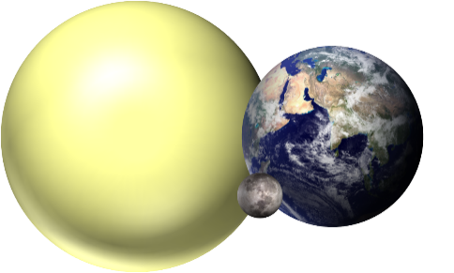
Sun, Moon and Earth

The Sun, Moon and Earth move through space.
The way they move gives us day and night, months and years

Which picture best shows how the Sun, Moon and Earth move?

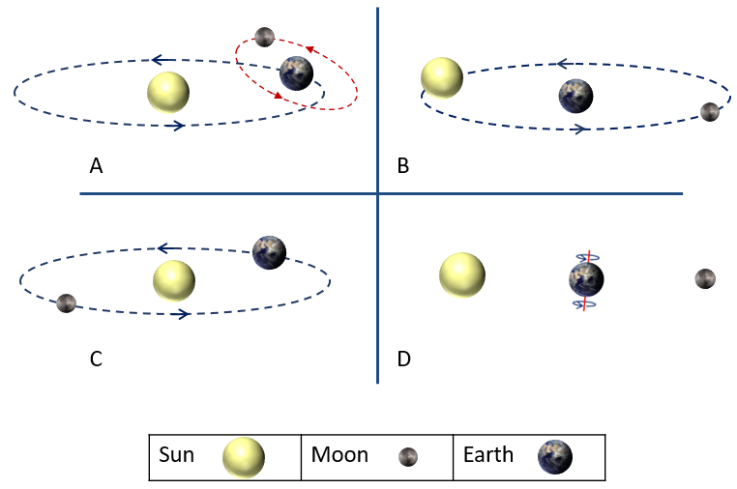
Physics > Big idea PES: Earth in space > Topic PES1: Solar System and beyond > Key concept PES1.1: Planets and the Solar System
Diagnostic question
Sun, Moon and Earth

Overview
Learning focus: | In the Solar System: eight planets orbit a star called the Sun; moons orbit most of the planets; and the planets spin on their axes. We live on the Earth where: a year is defined as the time for the Earth to orbit the Sun; a day as the time it takes the Earth to spin on its axis; and the Moon orbits in about 28 days. The planets are very small compared to the huge distances between them.
Observable learning outcome: | - Describe how the Earth orbits the Sun and explain what a year is.  - Describe how the Moon orbits the Earth and explain what a lunar month is.
Question type: | Diagnostic, simple multiple choice
Key words: | Earth, Sun, Moon, orbit, year, lunar month

P | PRIOR UNDERSTANDING  This diagnostic question probes understanding of ideas that are usually taught at age 5-11, to aid transition from earlier stages of learning.

What does the research say?
A study of thirty-two Tasmanian students identified a progression in students’ thinking from a model with the Earth at the centre, which was held by about three-quarters of the 9- and 10-year-olds, to a model with the Sun at the centre that is understood by the majority of the 11- and 12-year-olds (Jones, Lynch and Reesink, 1987). To correctly explain observable phenomena that are caused by movement of the Earth, Sun and Moon students need to understand the correct scientific model. If they are using a model that is incorrect students are likely to form further misunderstandings and about a quarter of 11- and 12-year-olds are using incorrect models.
One of the key findings of Lelliott and Rollnick's (2009) review of astronomy education research (1974-2008) was the need for teachers to use physical models both to scaffold learning and to challenge misunderstanding. This question can be used to identify which model different students are using.
Ways to use this question
Students should complete the question individually. This could be a pencil and paper exercise, or you could use an electronic ‘voting system’ or mini white boards and the PowerPoint presentation.
The answers to the question will show you whether students understood the concept sufficiently well to apply it correctly.
If there is a range of answers, you may choose to respond through structured class discussion. Ask one student to explain why they gave the answer they did; ask another student to explain why they agree with them; ask another to explain why they disagree, and so on. This sort of discussion gives students the opportunity to explore their thinking and for you to really understand their learning needs.
Differentiation
You may choose to read the questions to the class, so that everyone can focus on the science. In some situations it may be more appropriate for a teaching assistant to read for one or two students.
Expected answers
Model A is the correct answer. In this model the Earth is also spinning on its axis a total of 365¼ times each time it orbits the Sun.
How to respond - what next?
As their scientific understanding develops students tend to move from Earth-centred to Sun-centred thinking. In the answers this is shown in the progression D → B → C → A.
All four models can explain day and night if it is assumed that the Earth can spin on its axis. With model D it is not possible to explain changes during a year. With models B and C it is possible to explain day and night and what happens during a year’s time. Answer A can also account for the changes in shape of the Moon over a (lunar) month (of 28 days).
If students have misunderstandings about the model of Sun, Moon and Earth, it can help to use a physical model to demonstrate how day and night are caused, and to use it to challenge their misunderstandings. The following BEST ‘response activities’ could be used in follow-up to this diagnostic question:
- Response activity: Modelling the Earth
- Response activity: Modelling the Moon
Acknowledgments
Developed by Peter Fairhurst (UYSEG), based on illustrations in Making Sense of Secondary Science (Driver et al., 1994) which are originally from Children's conception of the Earth, Sun and Moon (Jones et al., 1987).
Images: CC0 Public Domain, Peter Fairhurst (UYSEG).
References
Driver, R., et al. (1994). Making Sense of Secondary Science: Research into Children's Ideas, London, UK: Routledge.
Jones, B. L., Lynch, P. P. and Reesink, C. (1987). Children's conception of the Earth, Sun and Moon. International Journal of Science Education, 9(1), 43-53.
Lelliott, A. and Rollnick, M. (2009). Big Ideas: A review of astronomy education research 1974-2008. International Journal of Science Education, 32:13, 1771-1799.

